Lab Taks-1

Submission Guidelines-
- Rename the file to your id only. If your id is 18-XXXXX-1, then the file name must be 18-XXXXX-1.docx.
- Must submit within the given deadline given in the class in VUES to the section named Lab Tak-1
- Must include resources for all the section in the table

Question-1
Draw the object-

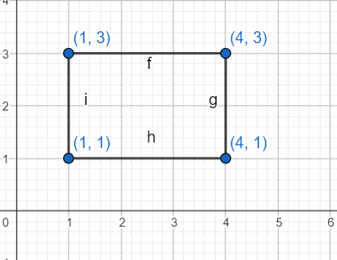
Graph Plot (Picture)-

Code-

Output Screenshot (Full Screen)-

Question-2
Draw the object-

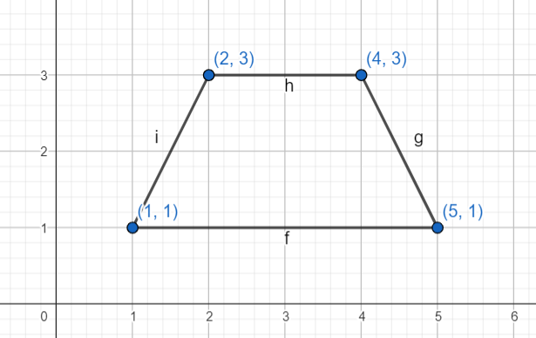
Graph Plot (Picture)-

Code-

Output Screenshot (Full Screen)-

Question-3
Draw the object-
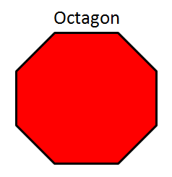

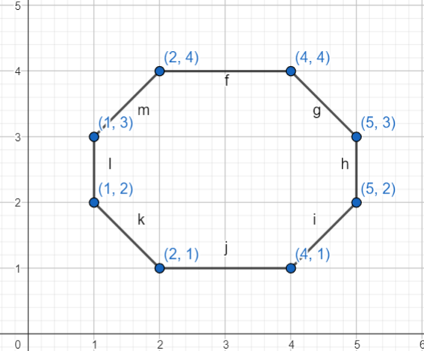
Graph Plot (Picture)-

Code-

Output Screenshot (Full Screen)-

Question-4
Draw the object-



Graph Plot (Picture)-

Code-

Output Screenshot (Full Screen)-

Question-5
Draw the object-

Graph Plot (Picture)-

Code-

Output Screenshot (Full Screen)-

Question-6
Draw the object-



Graph Plot (Picture)-

Code-

Output Screenshot (Full Screen)-

